**ASSIGNMENT 1**

**Task 1**

1. **Create the database named “TechShop”**

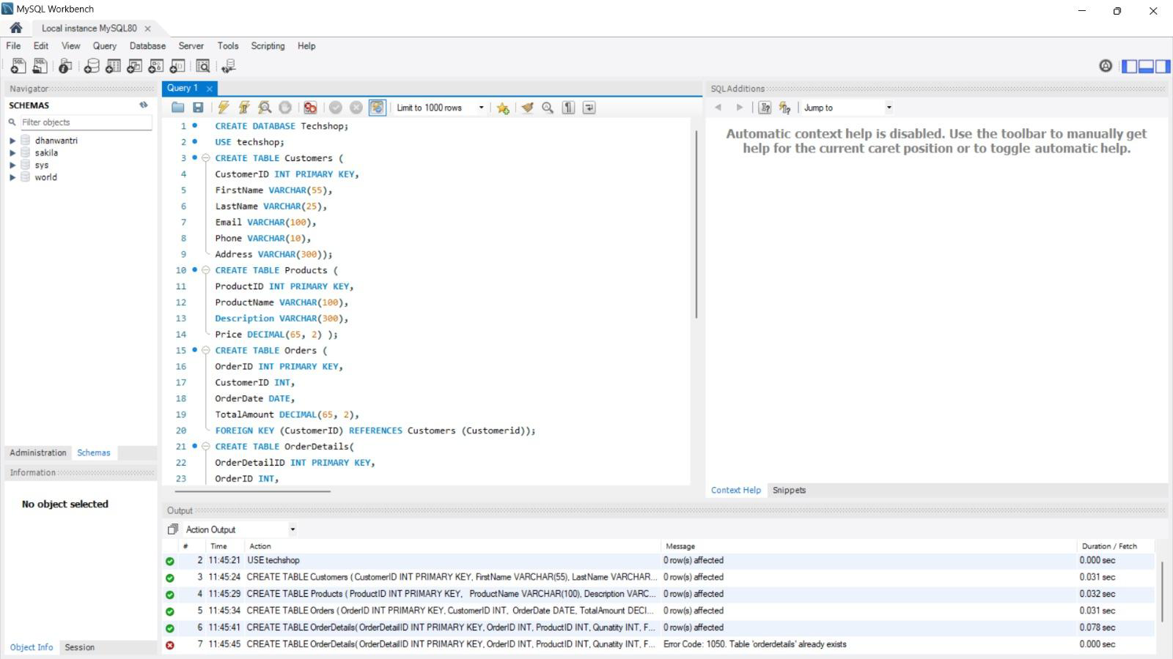

1. **Define the schema for the customers , Products, Orders, OrderDetails and inventory tables based on the provided schema**

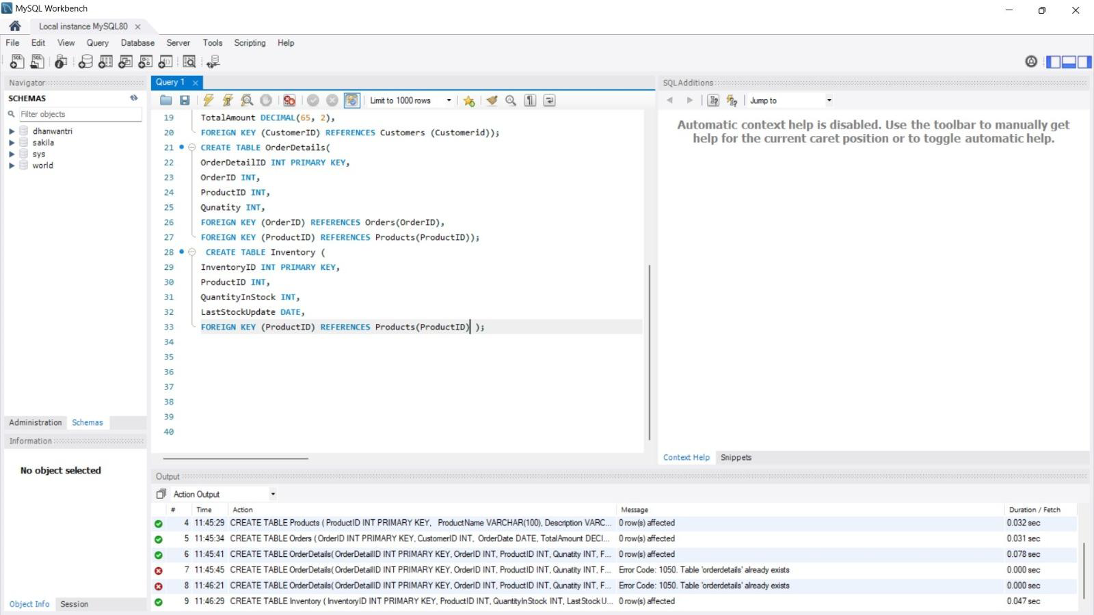

1. **Create an ERD for the database**

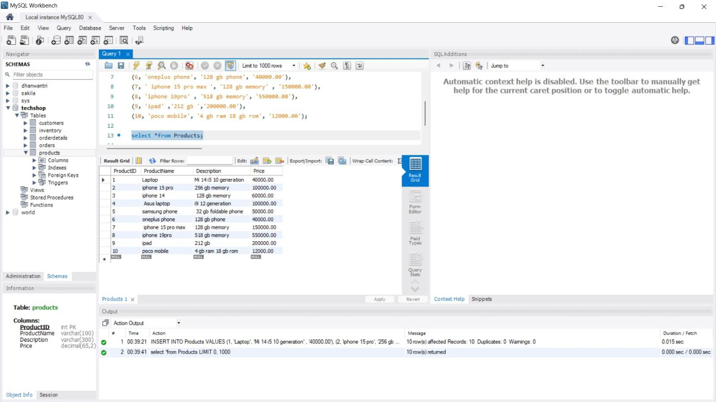

1. **Create appropriate primary key and foreign key constraints for referential integrity.**



1. **Insert at least 10 sample records into each of the following tables.**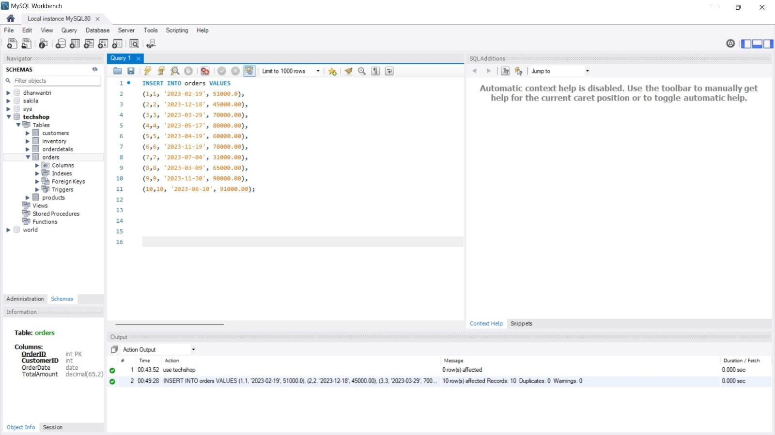

**Customers**

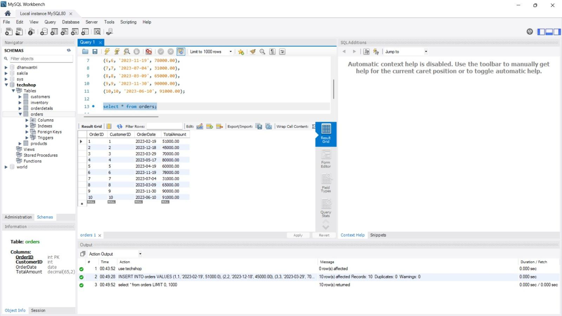

**Products**

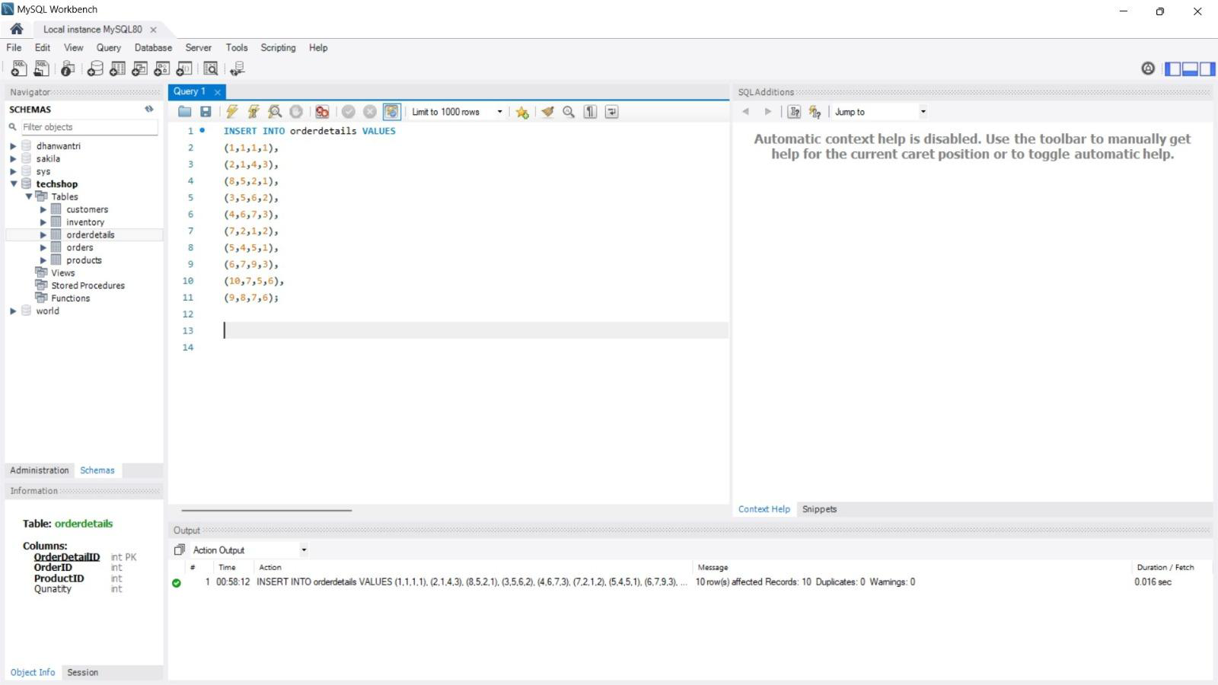

**Orders**

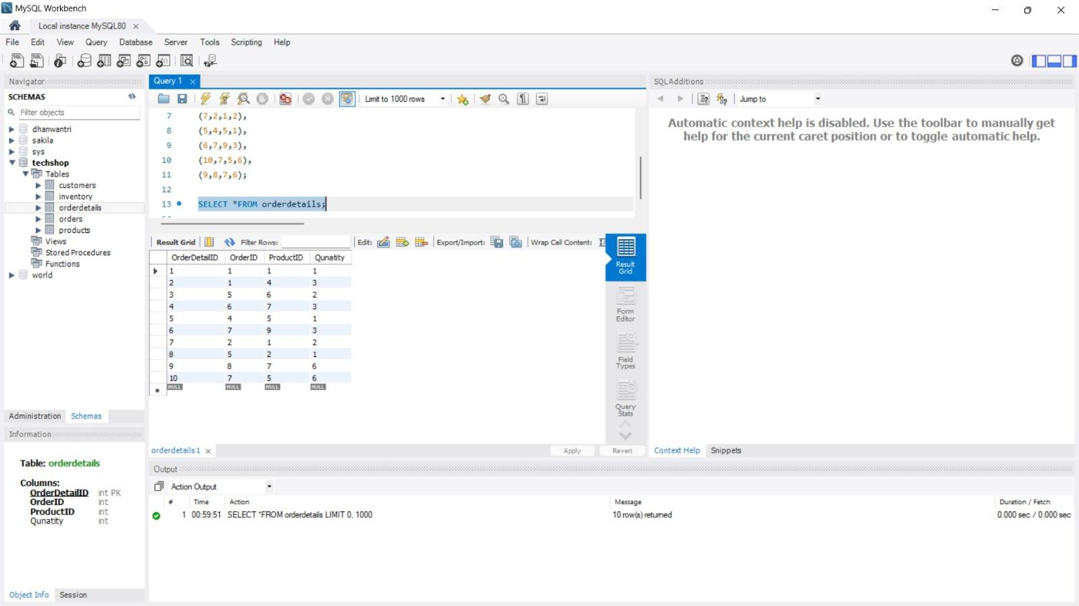

**OrderDetails**

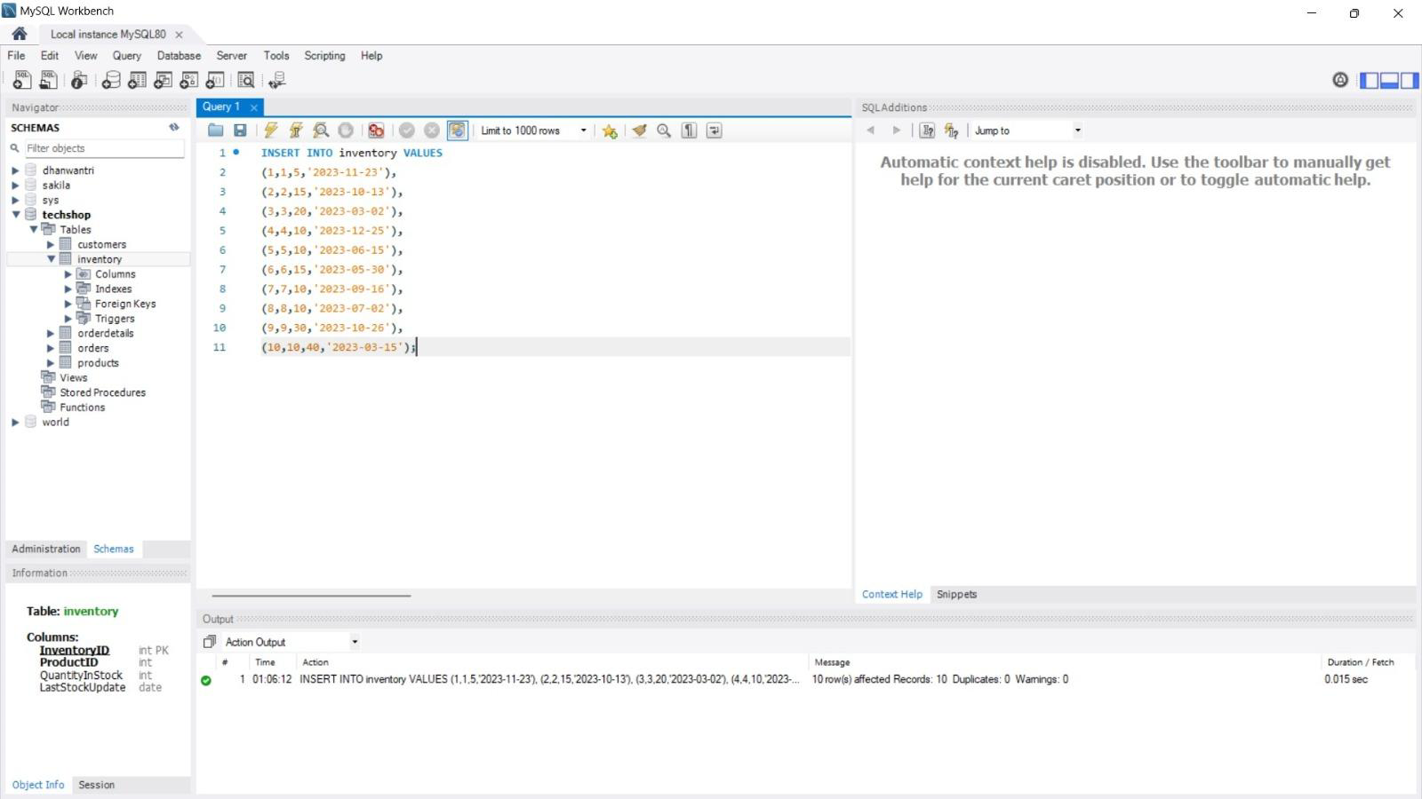

**Inventory**

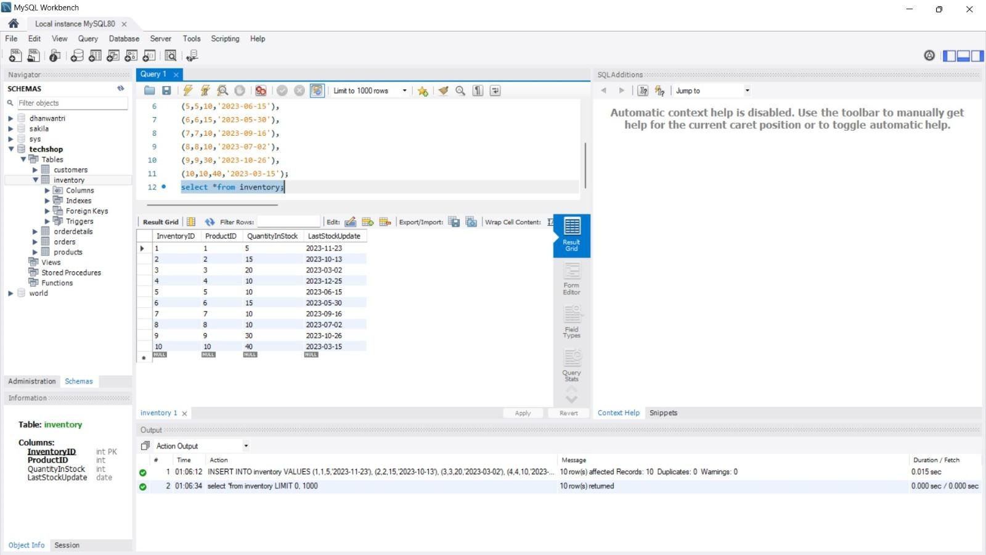

**Task 2**

1. **Write a SQL query to retrieve the names and emails of all customers**

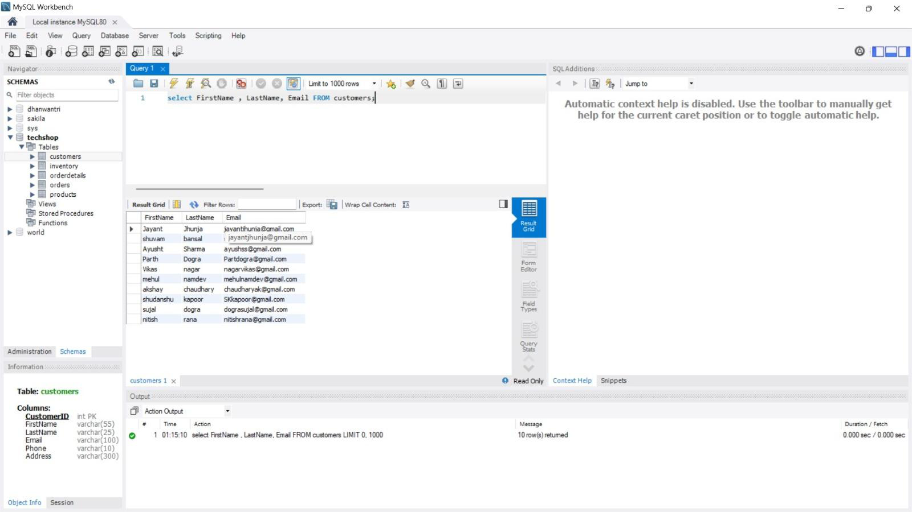

1. **Write a sql query to list all orders with their order dates and corresponding customer names.**

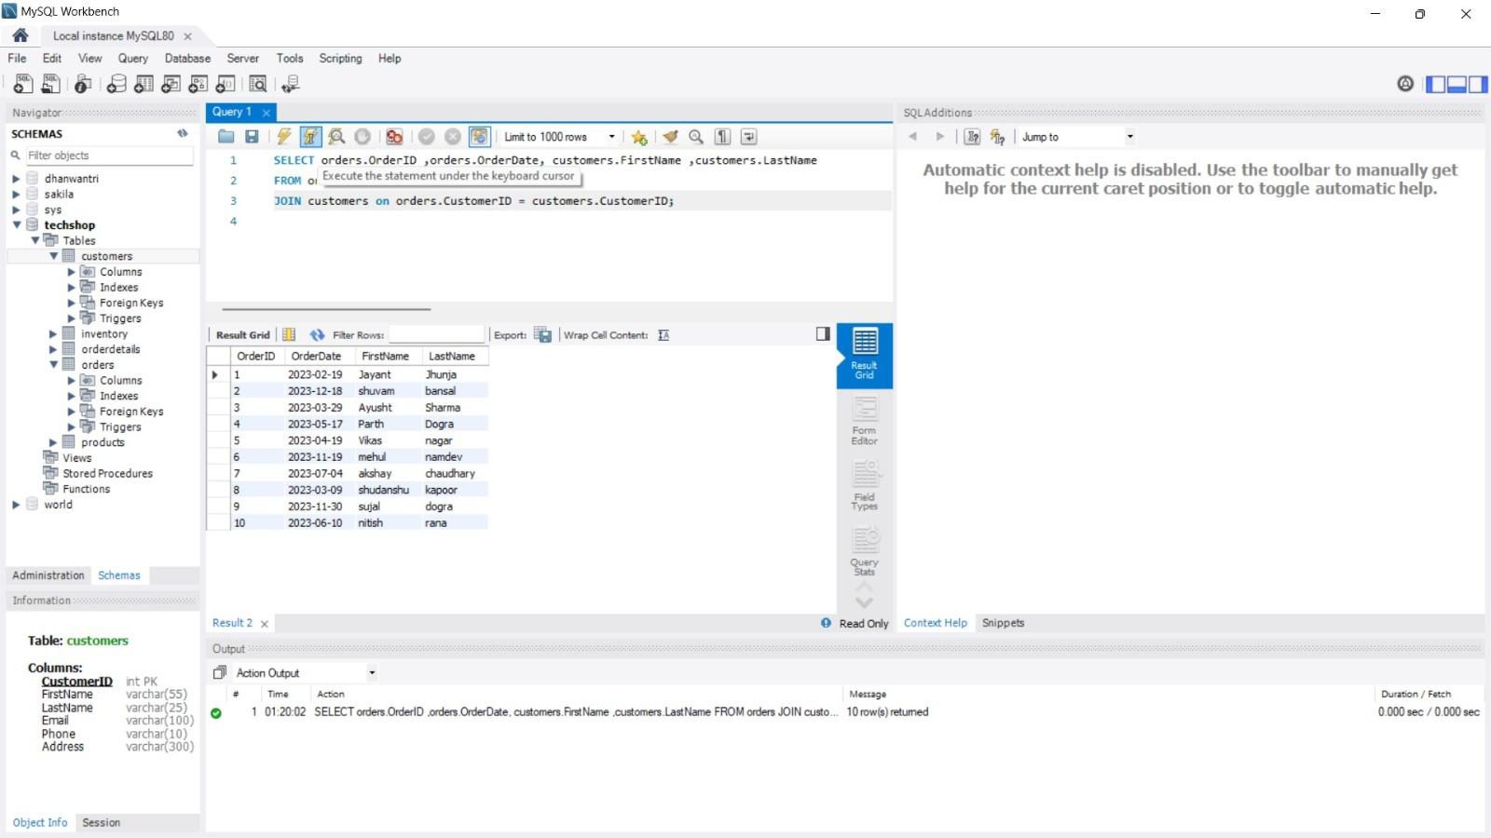

1. **Write a sql query to insert a new customer record into the “customers” table. Include customer information such as name, email , and address.**

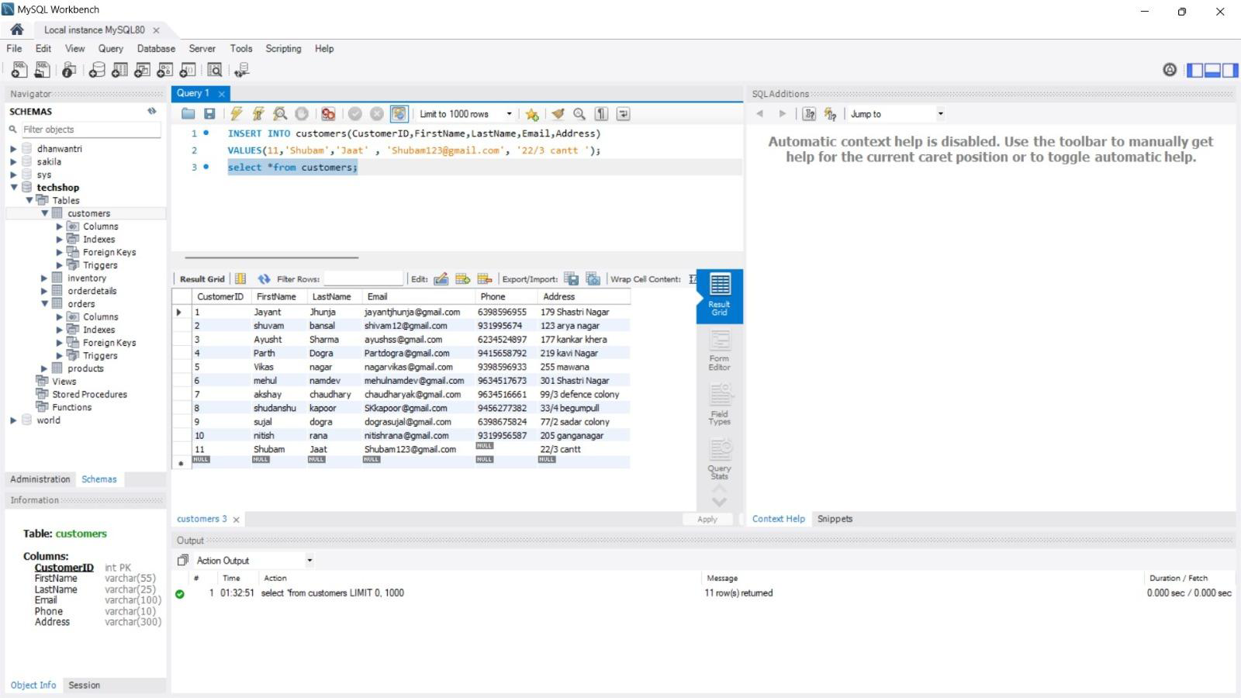

1. **Write a sql query to update the prices of all electronic gadgets in the “Products” table by increasing them by 10%**

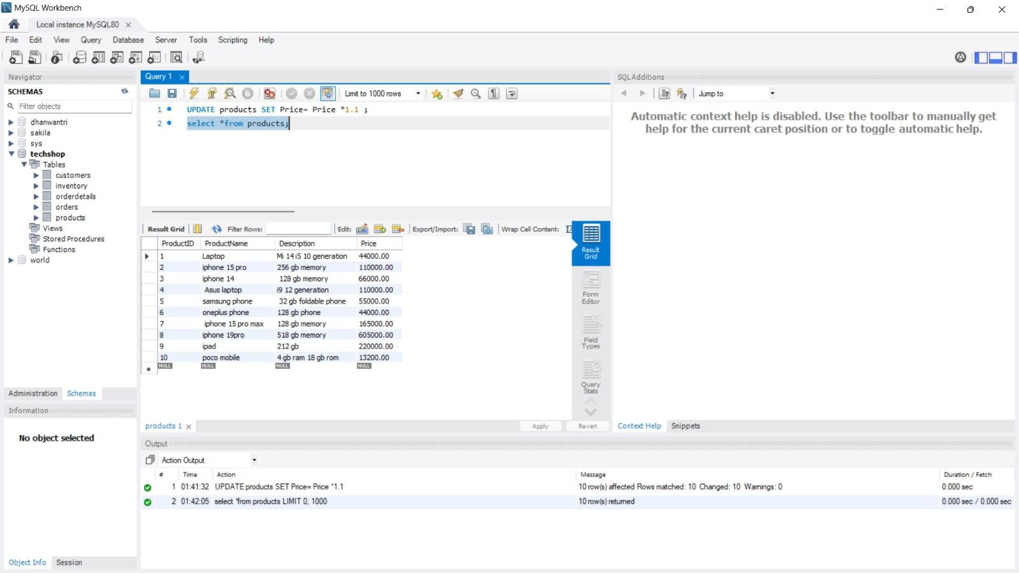

1. **Write a sql query to delete a specific order and its associated order details from the “orders” and “order details” tables. Allow users to input the order ID as a parameter.**

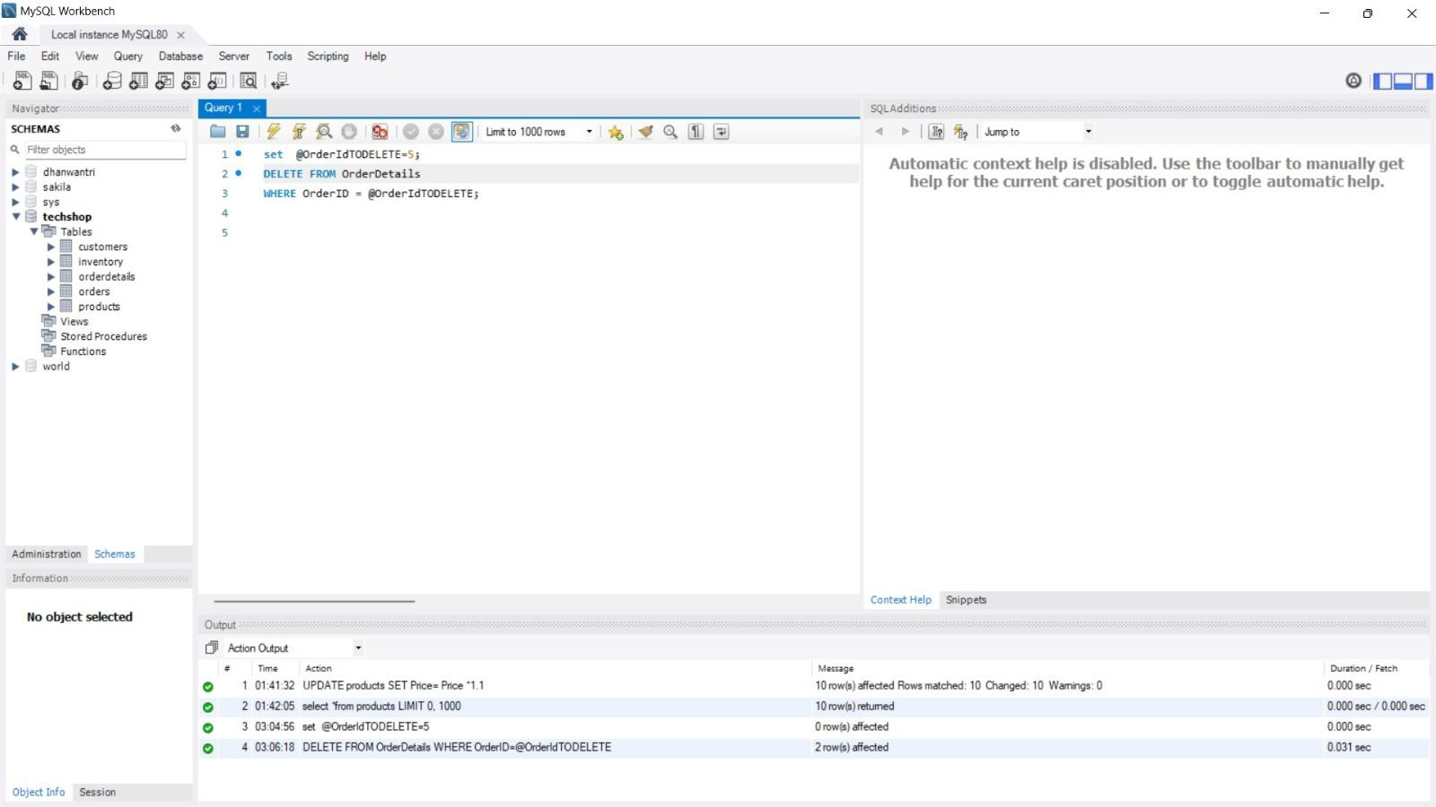

1. **Write a sql query to insert a new order into the “orders” table. Include the customer ID , order date and any other necessary information.**

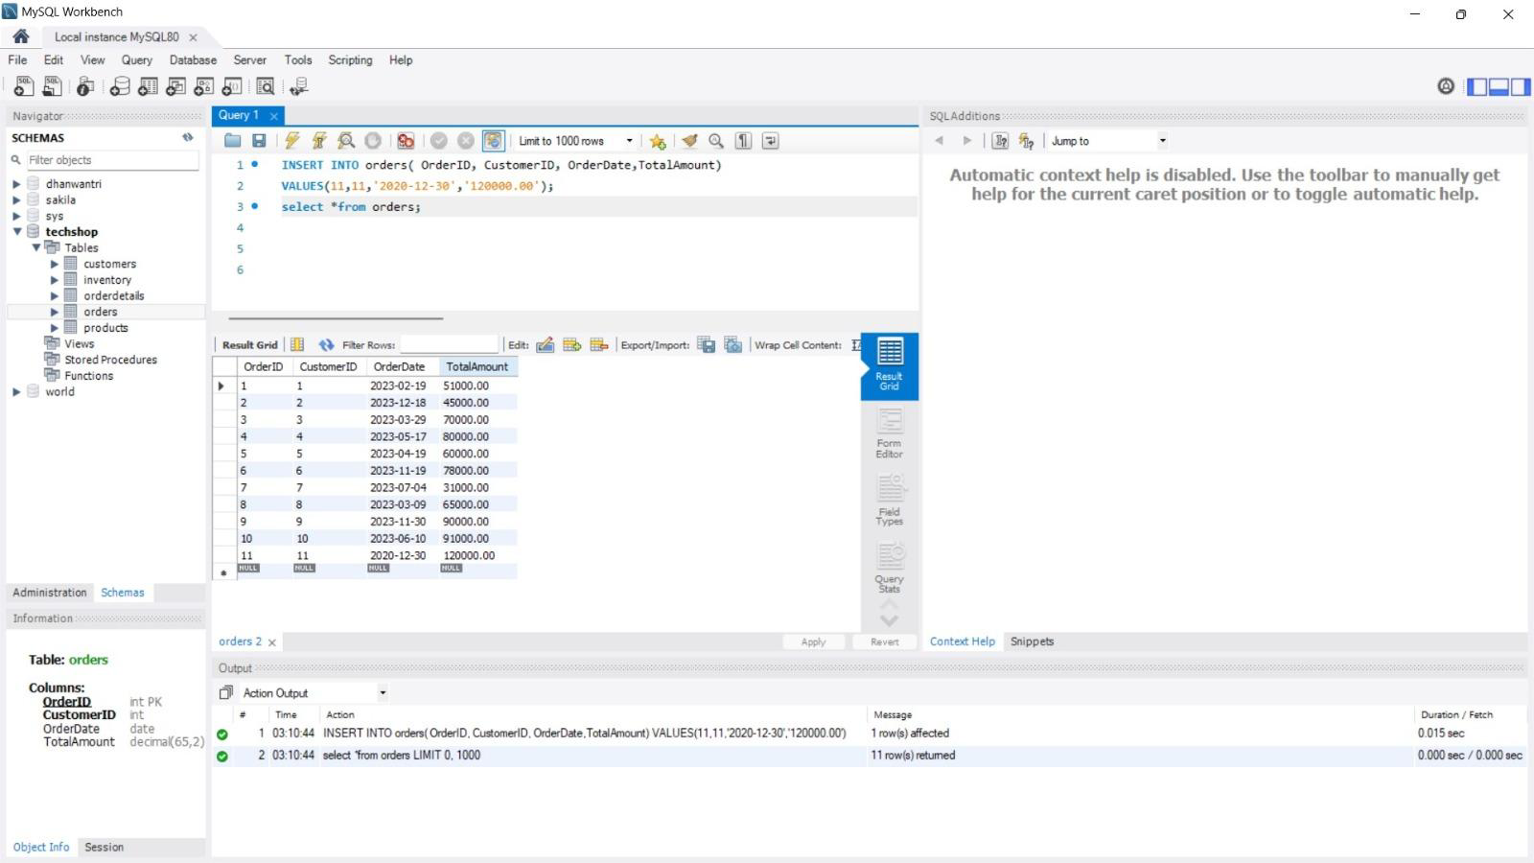

1. **Write a sql query to update the contact information of a specific customer in the “customer” table. Allow users to input the customer ID and new contact information**

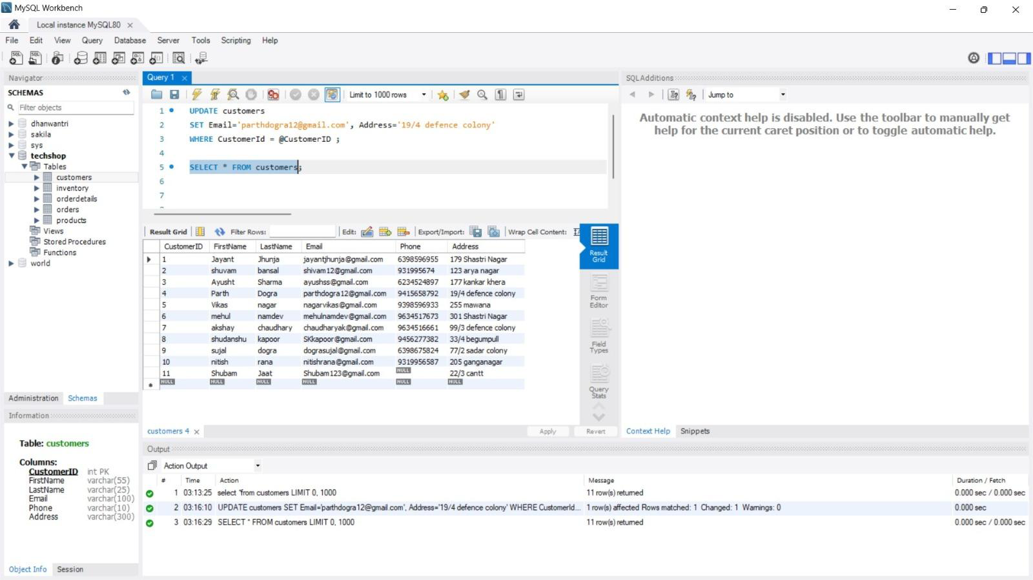

1. **Write a sql query to recalculate and update the total cost of each order in the “orders” table based on the prices and quantities in the “orderdetails” table.**

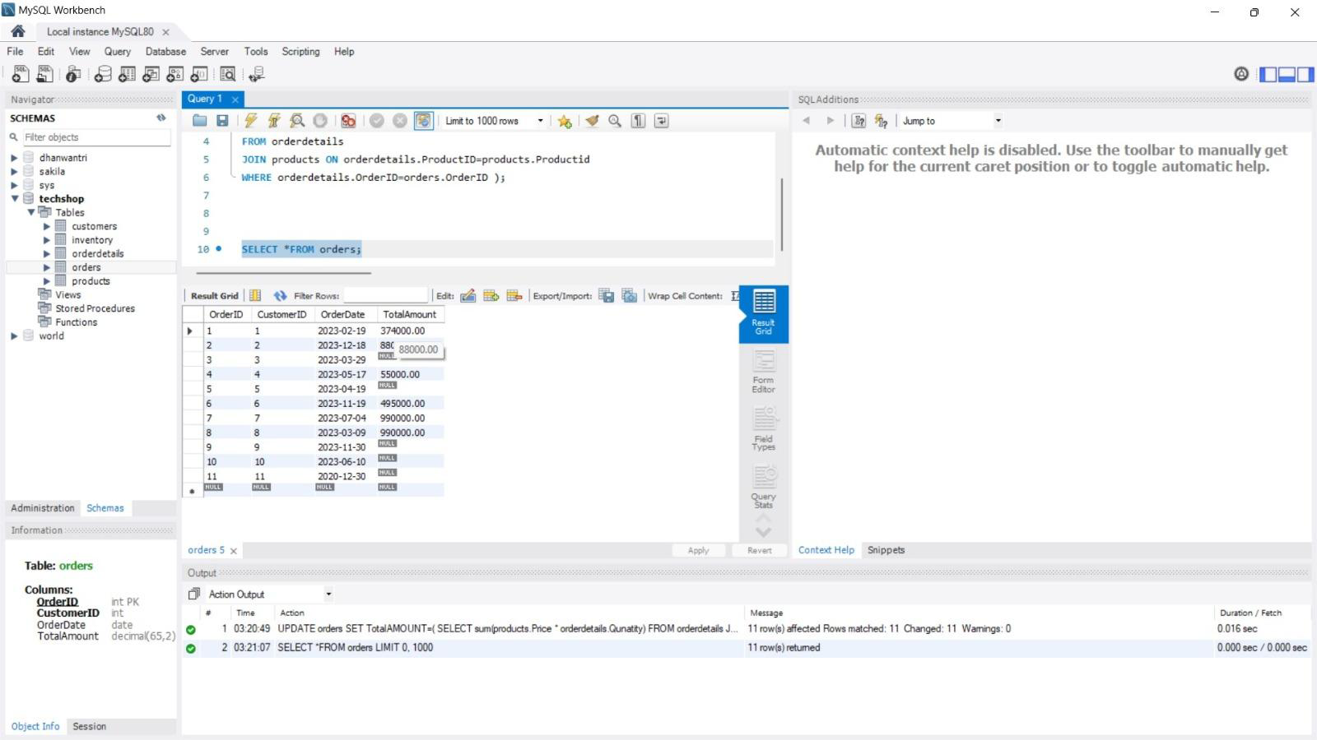

1. **Write a sql query to delete all orders and their associated order details for a specific customer from the “orders” and “orderdetails” table. Allow users to input the customer ID as a parameter.**

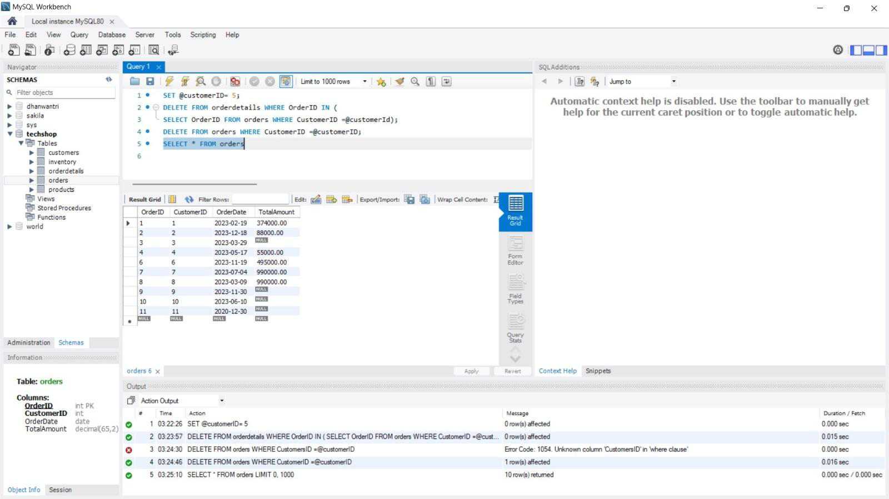

1. **Write a sql query to insert a new electronic gadget product into the “Products” table, including product name, category, price , and any other relevant details**

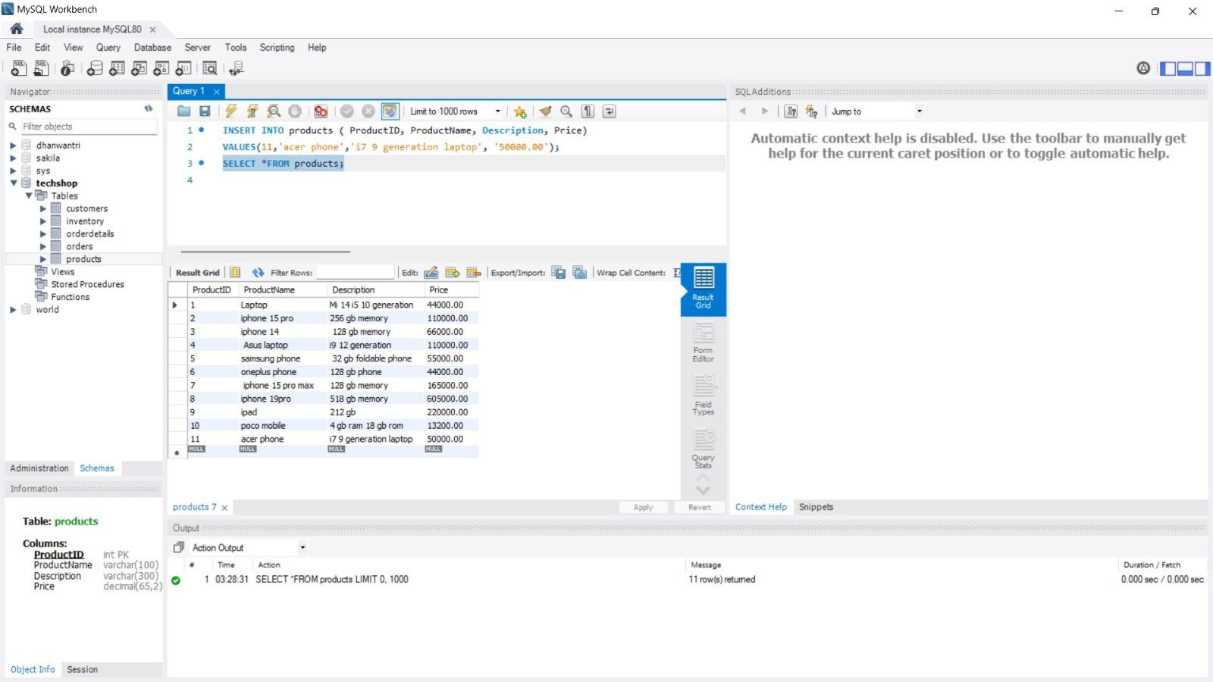

1. **Write a sql query to update the status of a specific order in the “orders” table . Allow users to input the order ID and the new status.**

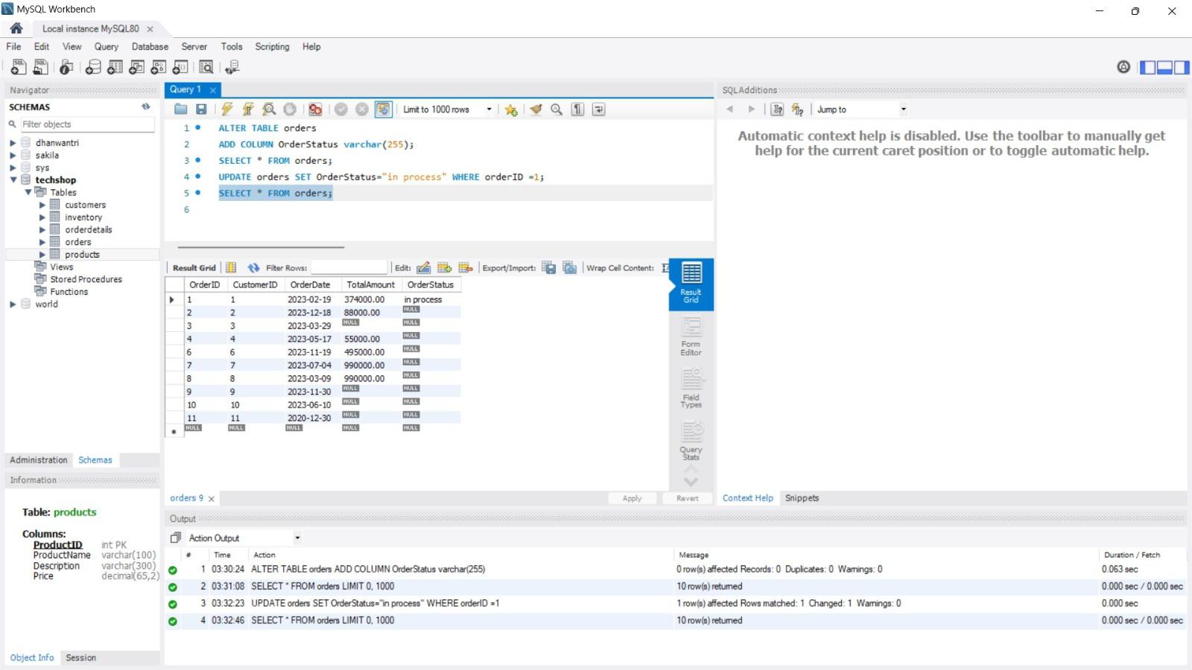

1. **Write a sql query to calculate and update the number of orders placed by each customer in the “customers” table based on the data in the “orders” table.**

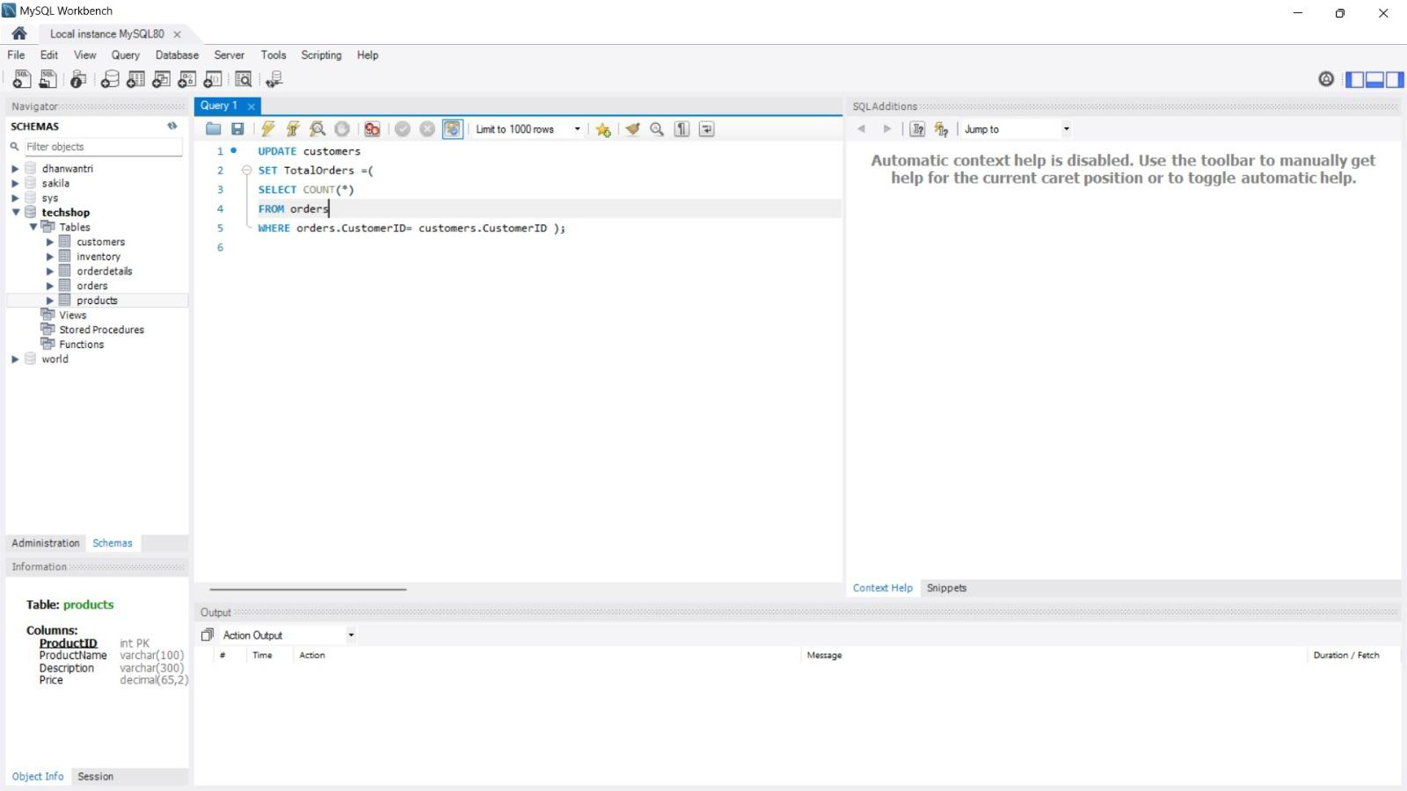

**Task 3**

1. **Write a sql query to retrieve a list of all orders along with customer information for each order.**

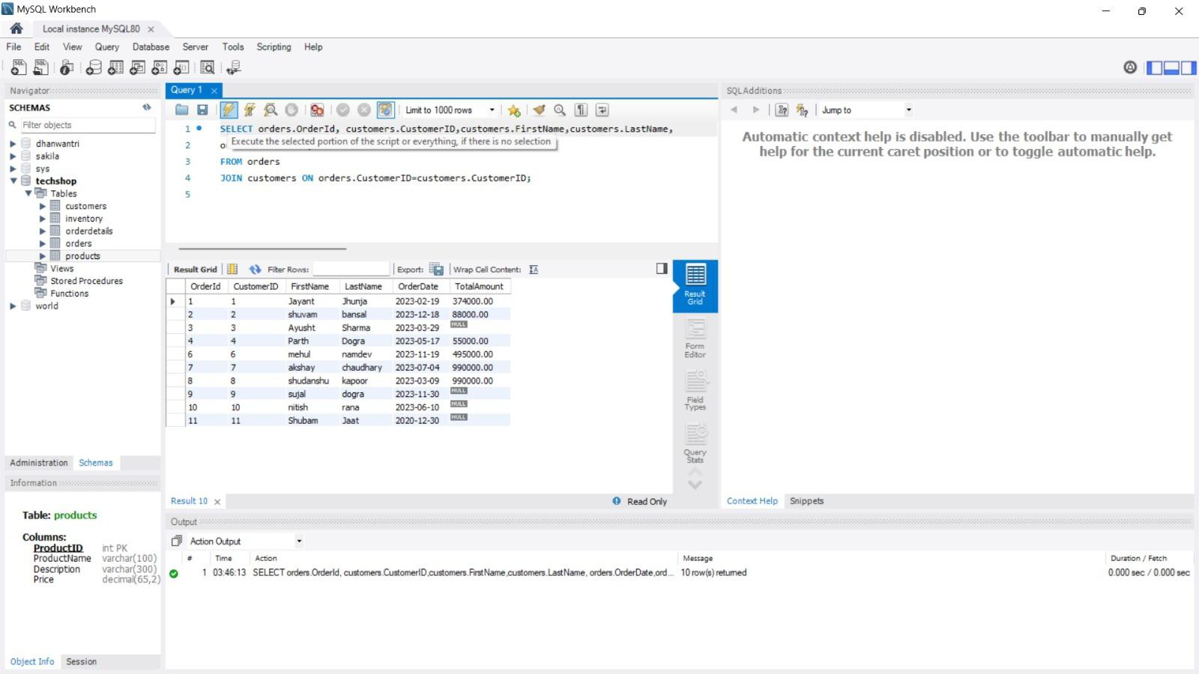

1. **Write a sql query to find the total revenue generated by each electronic gadget product. Include the product name and the total revenue.**

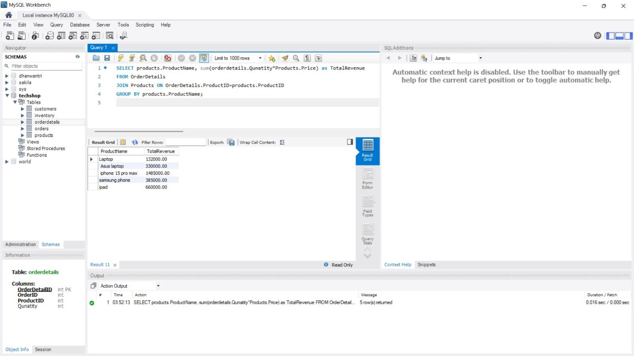

1. **Write a sql query to list all customers who have made at least one purchase, include their names and contact information.**

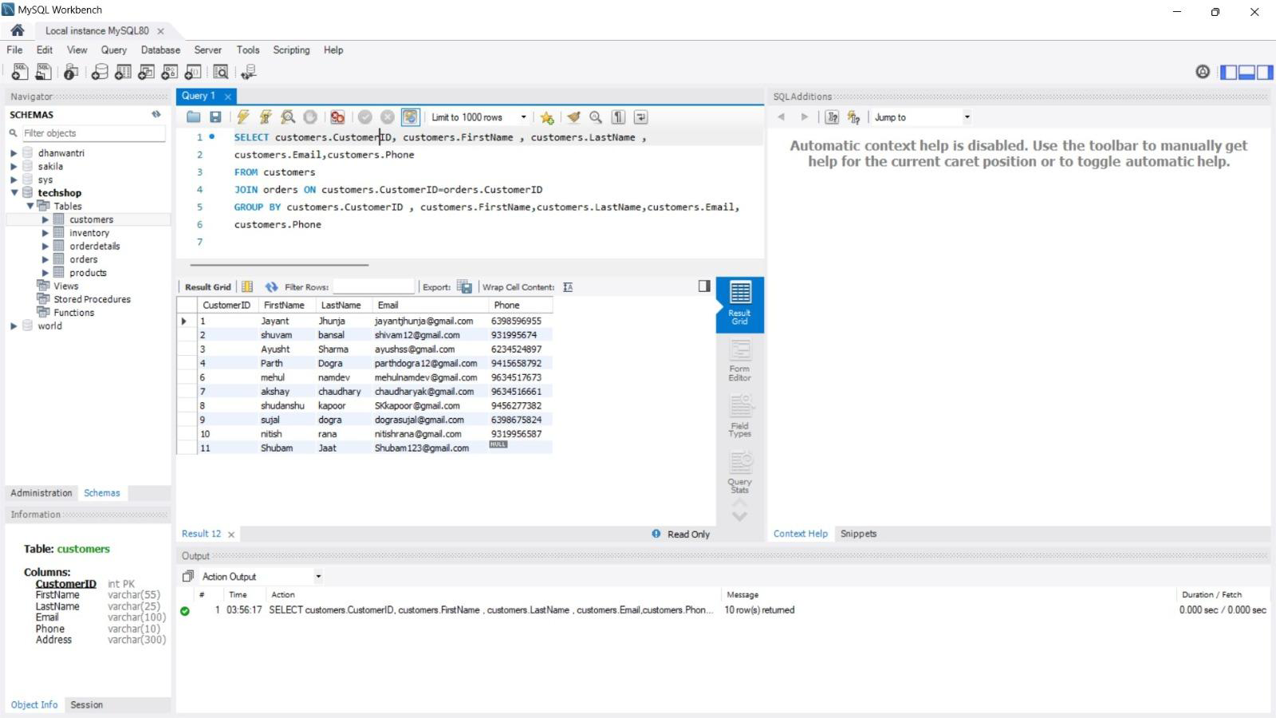

1. **Write a sql query to find the most popular electronic gadget which is one with the highest total quantity ordered. Include the product name and total quantity ordered**

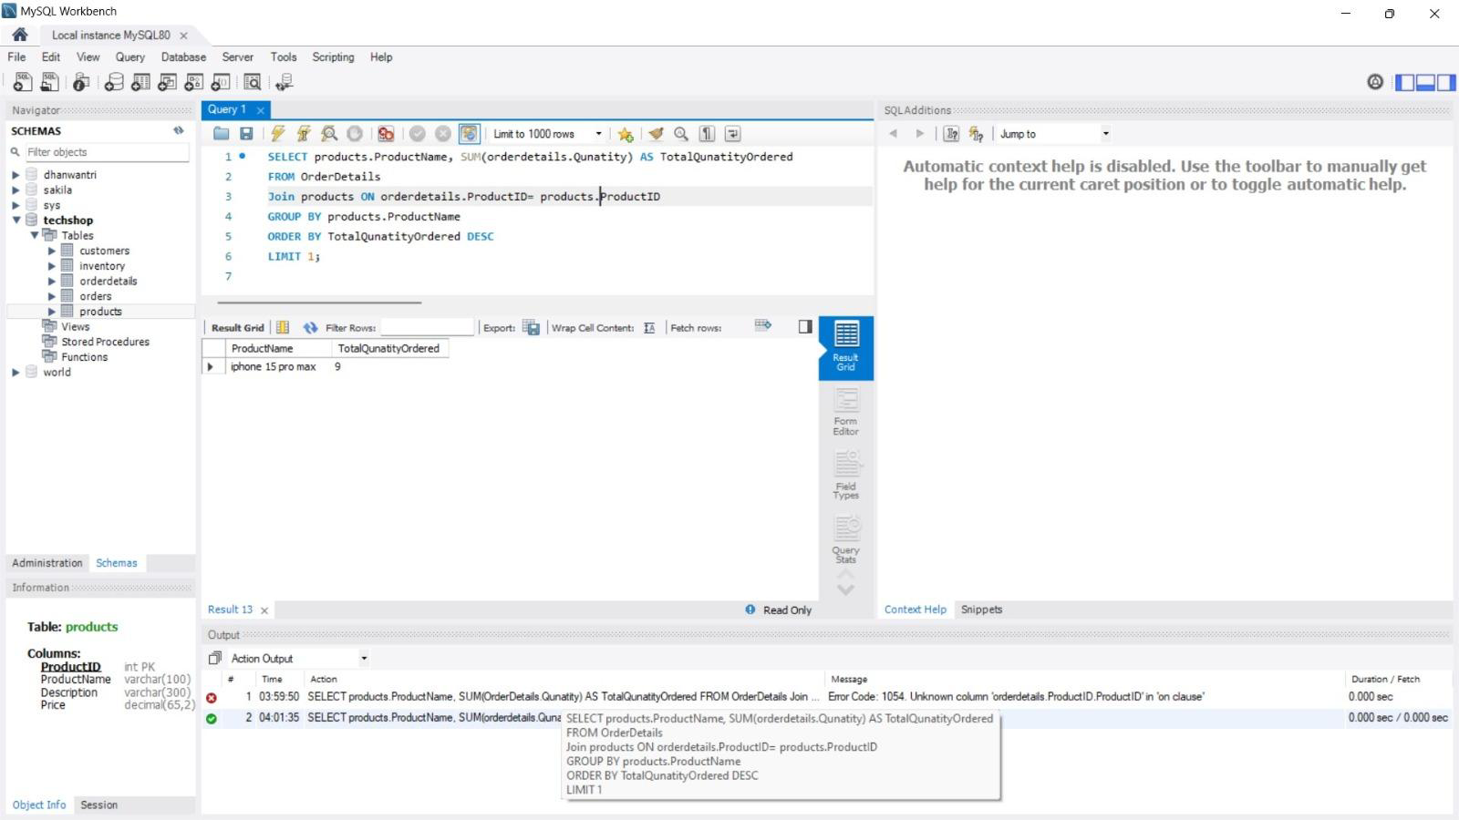

1. **Write a sql query to retrieve a list of electronic gadgets along with their corresponding categories.**

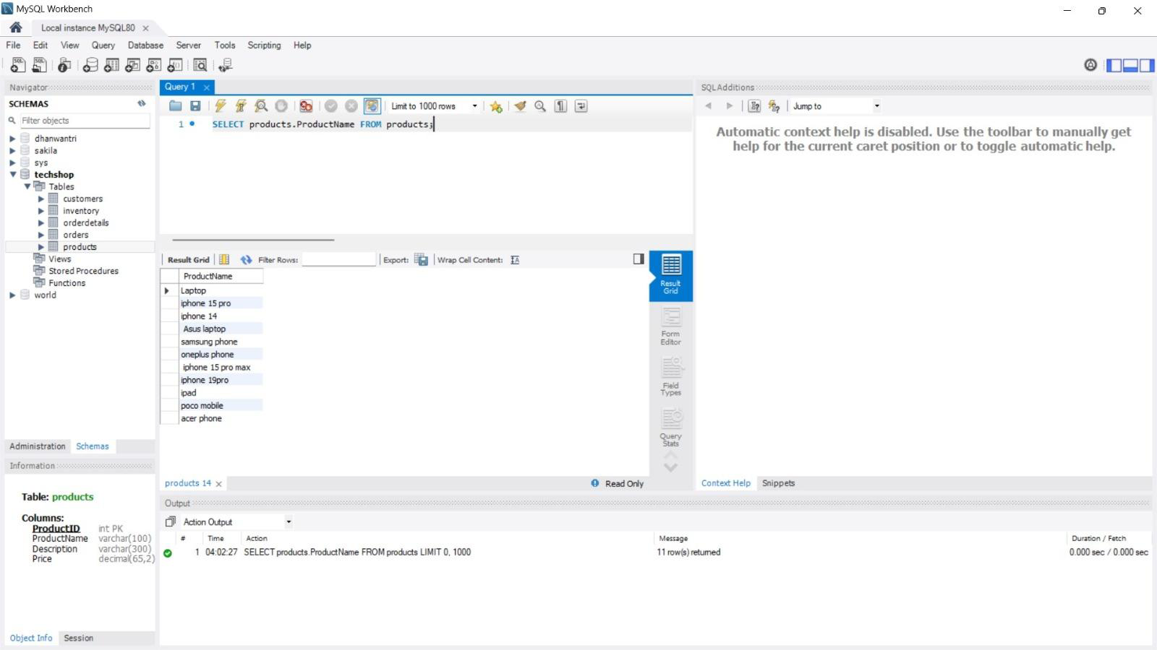

1. **Write a sql query to calculate the average order value for rach customer. Include the customers name and their average order value.**

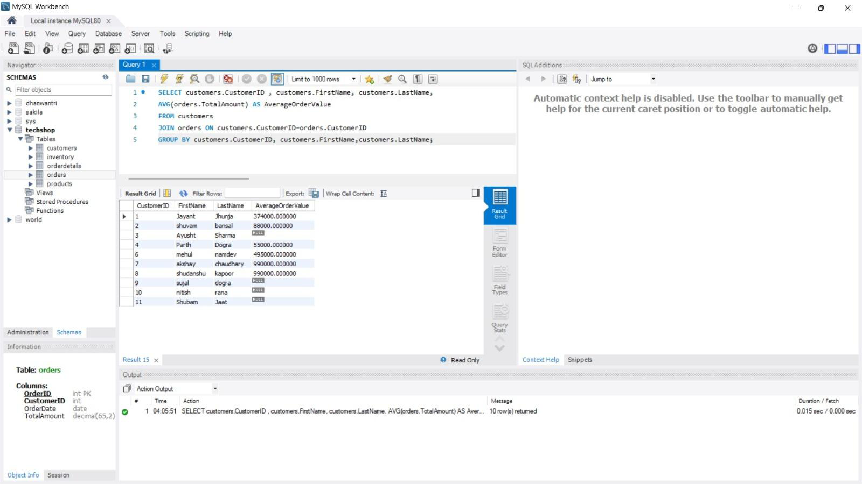

1. **Write a sql query to find the order with the highest total revenue. Include the order ID, customer information , and total revenue.**

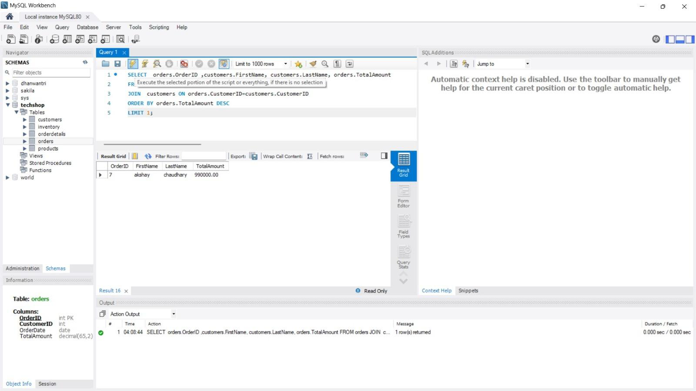

1. **Write a sql query to list electronic gadgets and the number of times each product has been ordered.**

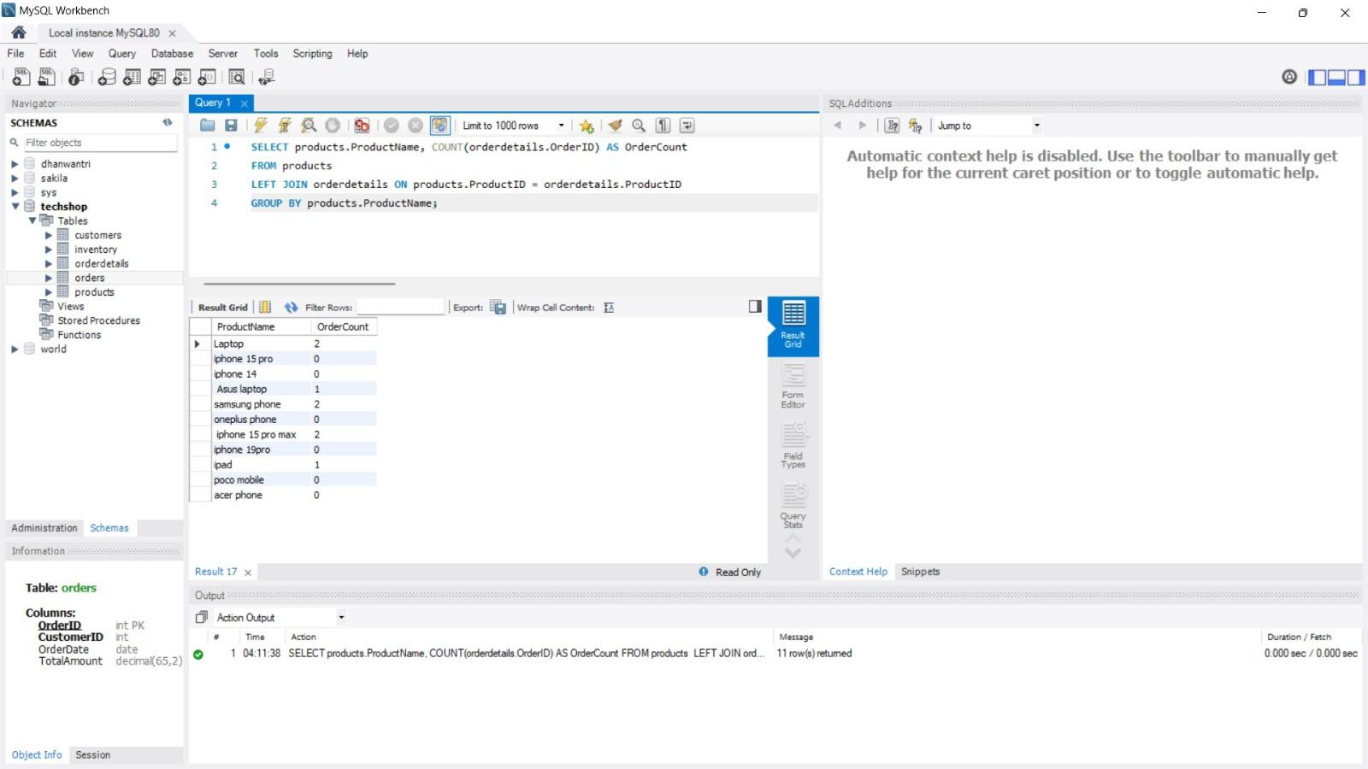

1. **Write a sql query to find customers who have purchased a specific electronic gadget product allow users to input the product name as a parameter**

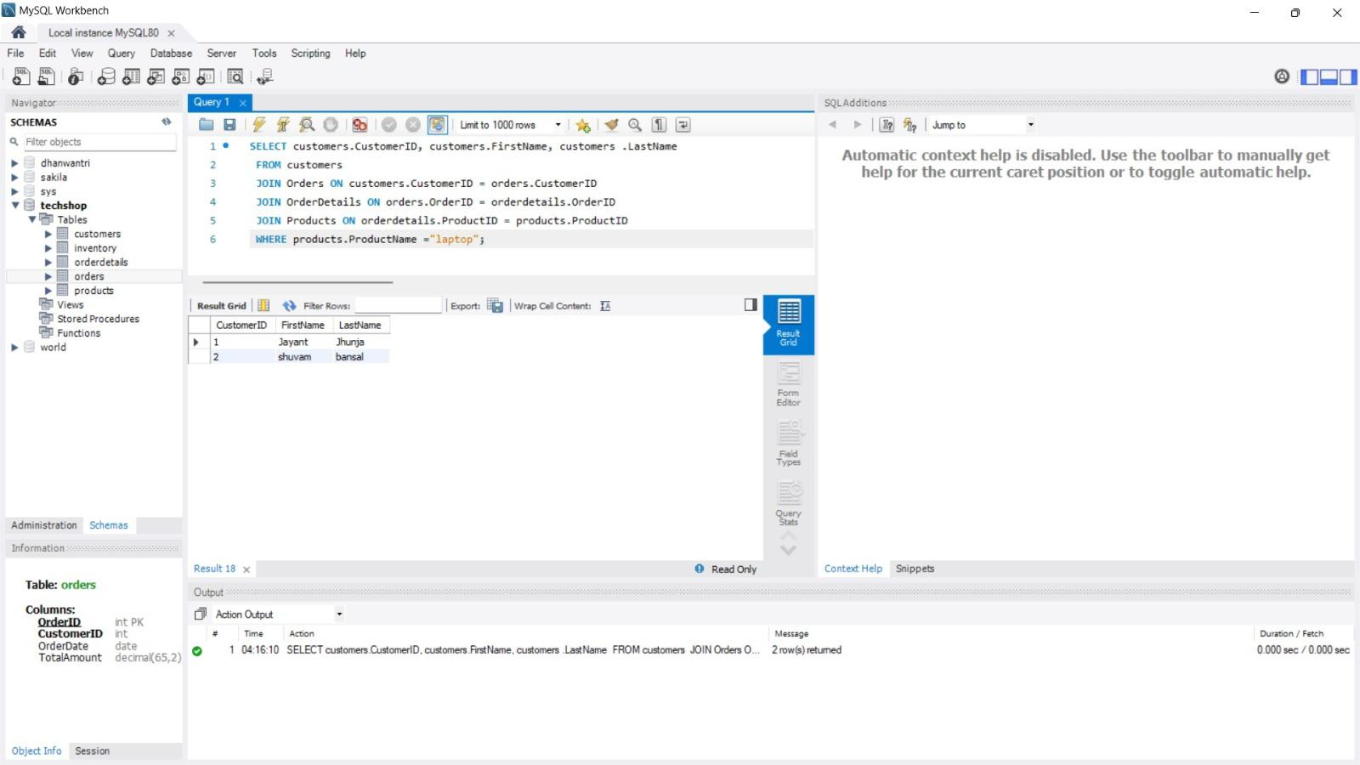

1. **Write a sql query to calculate the total revenue generated by all orders placed within a specific time period. Allow users to input the start and end dates as parameters.**

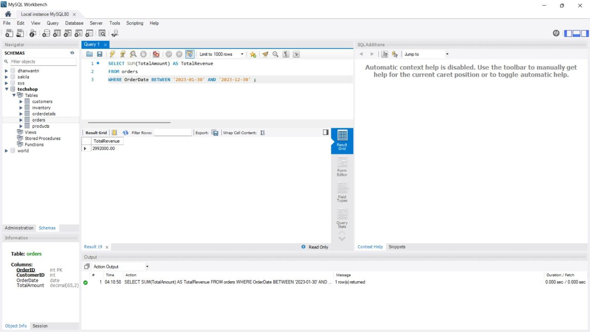

**Task 4**

1. **Write an SQL query to find out which customers have not placed any orders.**

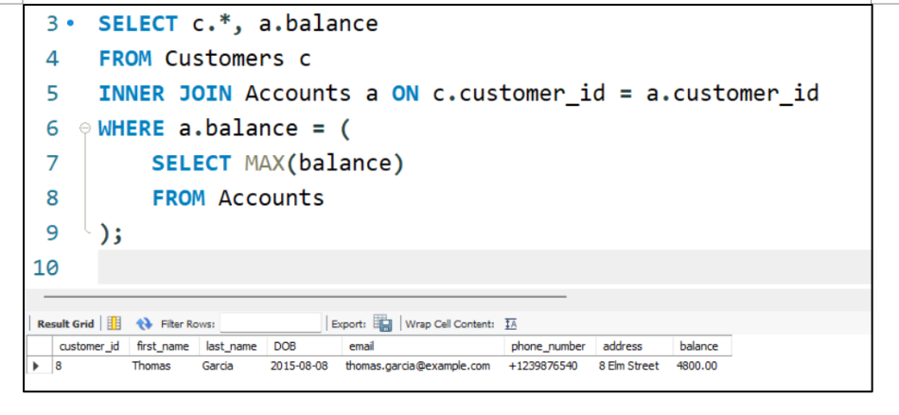

1. **Write an SQL query to find the total number of products available for sale.**

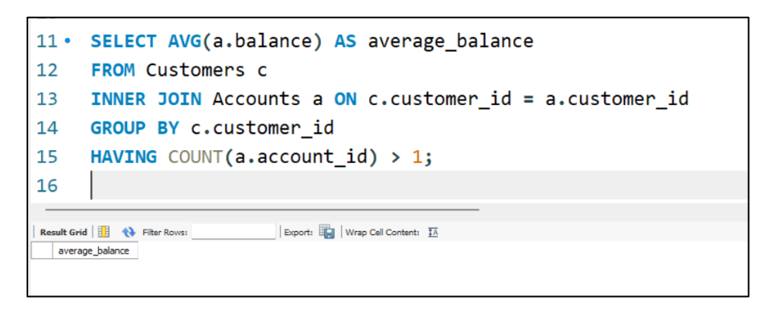

1. **Write an SQL query to calculate the total revenue generated by TechShop.**

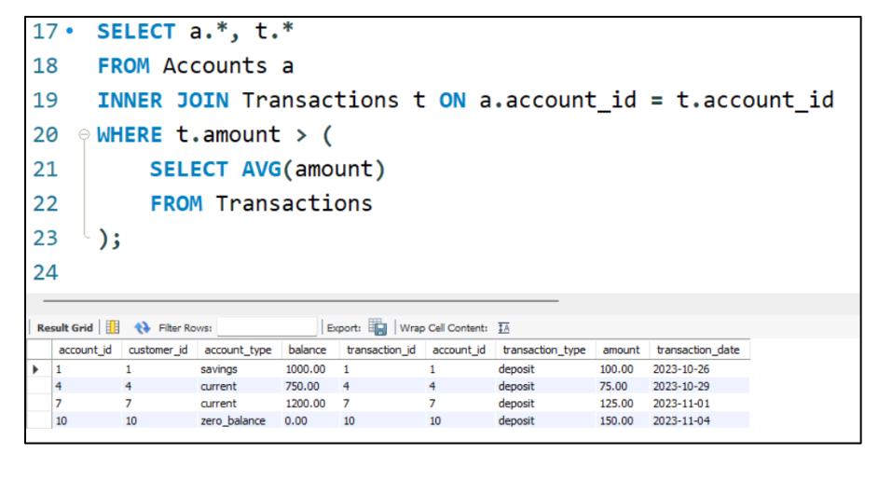

1. **Write an SQL query to calculate the average quantity ordered for products in a specific category. Allow users to input the category name as a parameter.**

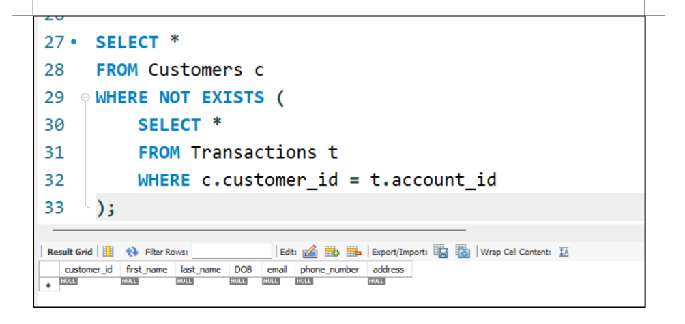

1. **Write an SQL query to calculate the total revenue generated by a specific customer. Allow users**

**to input the customer ID as a parameter.**

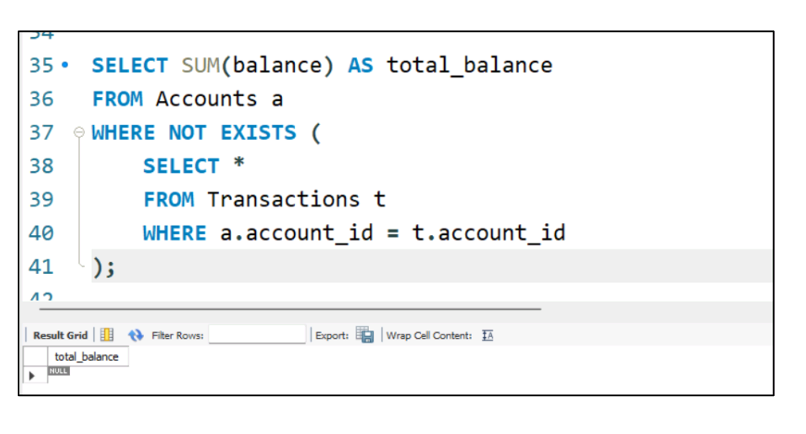

1. **Write an SQL query to find the customers who have placed the most orders. List their names and the number of orders they've placed.**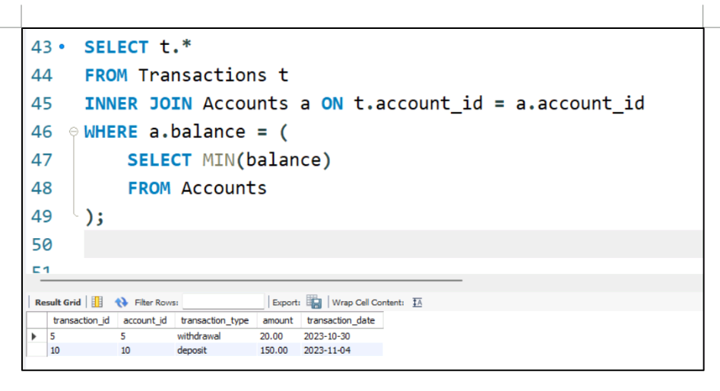
2. **Write an SQL query to find the most popular product category, which is the one with the highest total quantity ordered across all orders.**

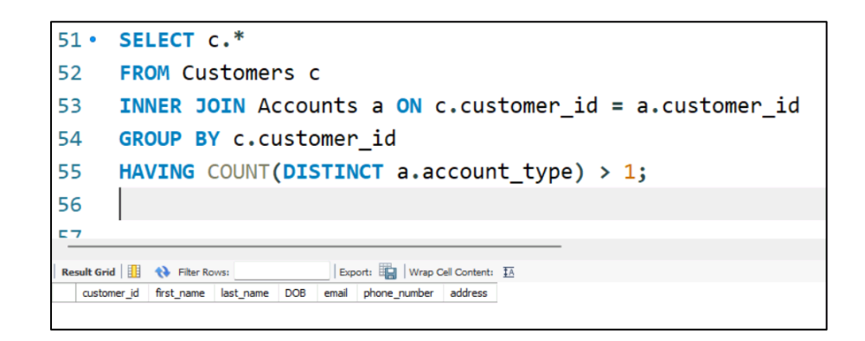

1. **Write an SQL query to find the customer who has spent the most money (highest total revenue) on electronic gadgets. List their name and total spending.**

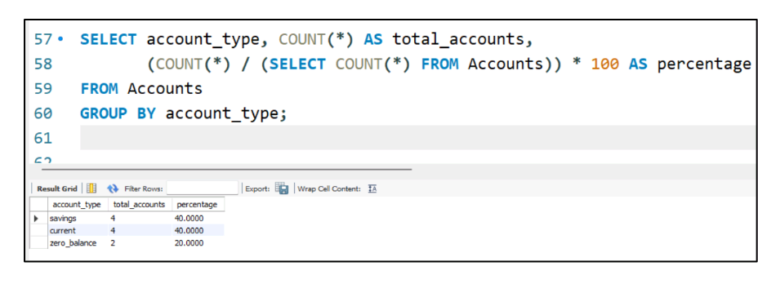

1. **Write an SQL query to calculate the average order value (total revenue divided by the number of orders**

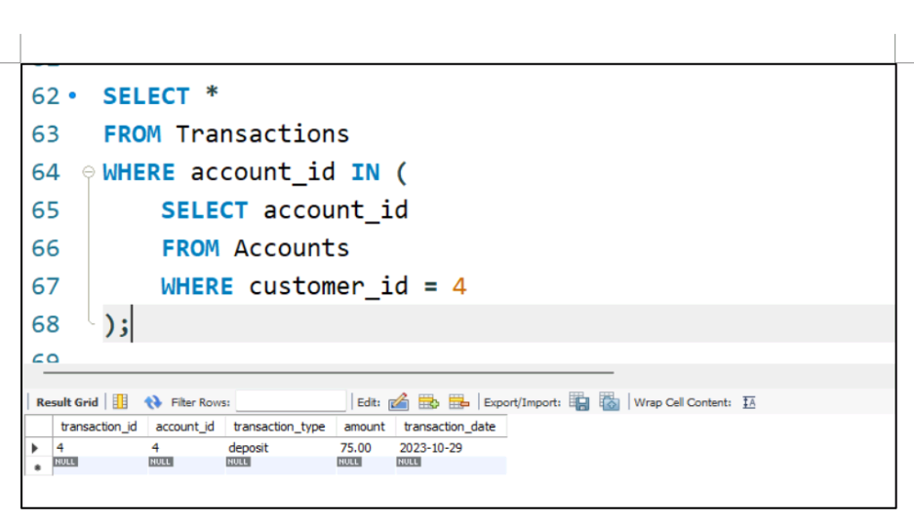

1. **Write an SQL query to find the total number of orders placed by each customer and list their names along with the order count.**

